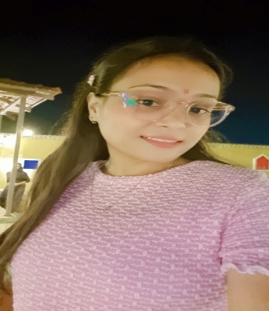

***Frontend developer-***

HTML, CSS, JS

***Language* -** C++

***Libraries/Framework*-** ReactJS, NodeJS, Angular

***Database*-**MongoDB

**Interested In-**

Coding

Web designing

***Shruti Bansal***

* **Ecommerce [Food-Order]**
* This project helps people will purchase the food online at home.
* Tech stack- HTML, CSS, JavaScript, ReactJS.
* **[School Website]**
* This project helps us to create a dynamic website
* Tech stack- By helping Bootstrap, CSS, NodeJS, MongoDB.
* **[portfolio website]**
* Tech stack- HTML, CSS.

|  |  |
| --- | --- |
| **2020** | Pursuing B Tech (computer science)  RGPV University, Bhopal  CGPA 8.3[till VI semester] |
| **2020** | Passed out 12th from MP board  Scored: 75% |
| **2018** | Passed out 10th from CBSE board  CGPA:6.7 |

***Projects***

I have a 1.5 months experience in TECHOBUILD Pvt Ltd as an Intern.

In which I have completed almost **June 2023 to July 2023.** 2+

projects. And I have an experience in ReactJS and NodeJS.

I have also done the portfolio website.

***Experience***

7024436987

***Personal Details-***

***Father’s Name* –**Mr. Hukum Chand Bansal

***Mother’s name*** –Mrs. Ruby Bansal

***Date of Birth* –** 16-10-2001

***Nationality* –**  Indian

***Language Known* –** Hindi/ English

***Permanent Address* –** In front of Morena talkies Saroj tower A block 401 flat no. Rui ki mandi.

Morena (M.P.)

***Educational background***

***Location –*** Morena, (M.P.)

***Linked In -*** [www.linkedin.com/in/shruti-bansal-11626b213](http://www.linkedin.com/in/shruti-bansal-11626b213)

***GitHub-*** [shruti-bansal(github.com)](https://github.com/shruti-bansa)

Bansalshruti798@gmail.com